Exp 10. Create a Cloning of a VM and Test it by loading the Previous Version/Cloned VM using virtual

box.

Step 1: Open the virtual box and choose the Existing OSI file

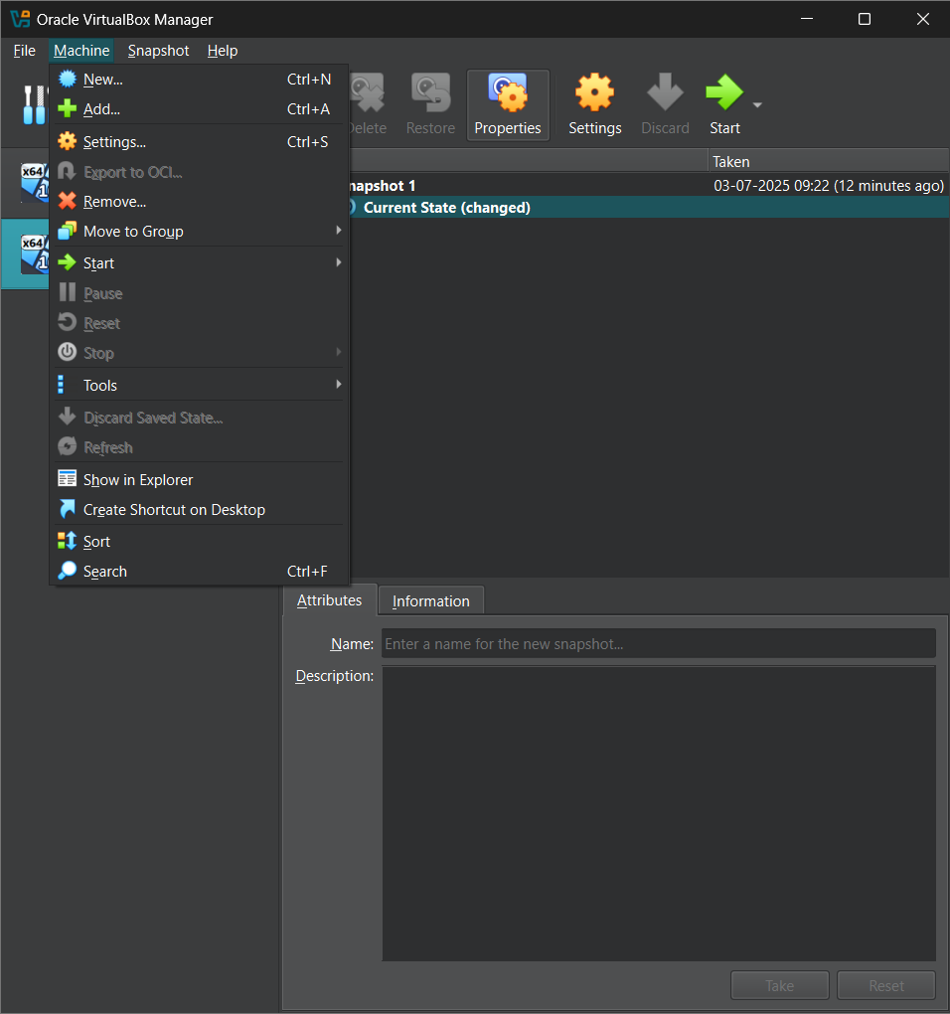

Step 2: Choose the machines and click on the new option

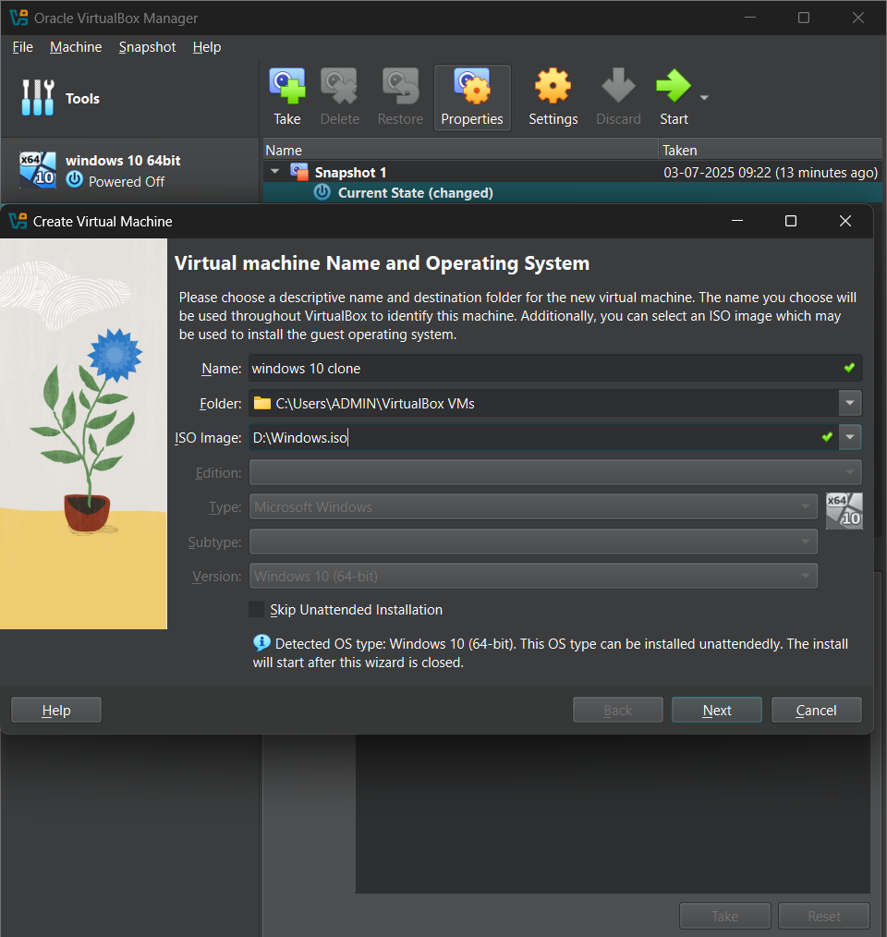

Step 3:

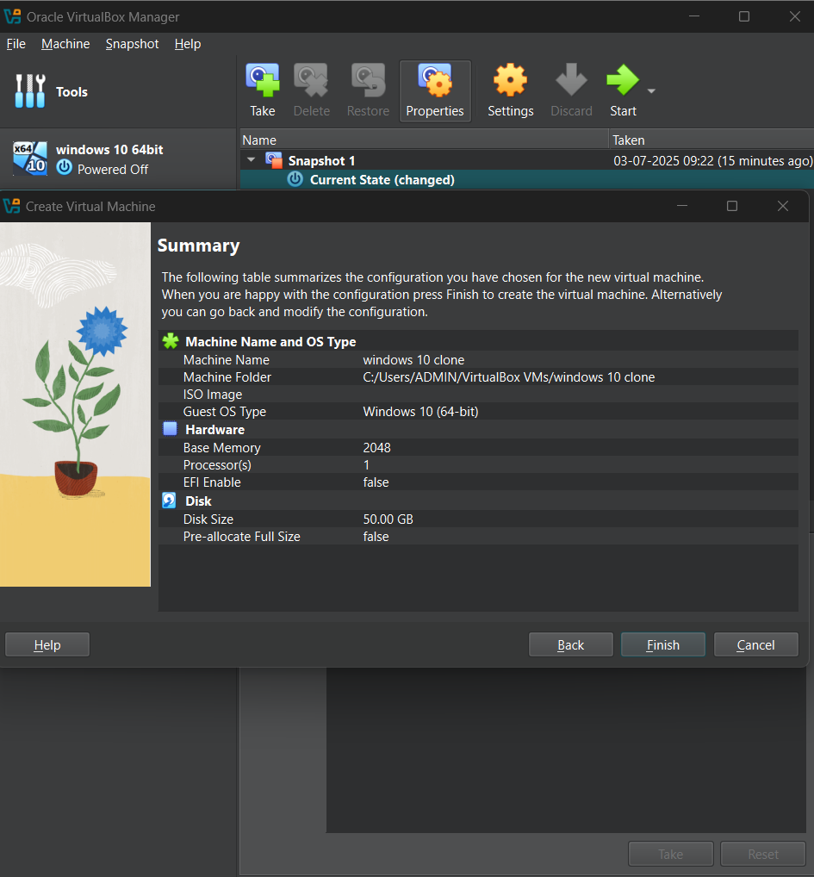

Step 4:

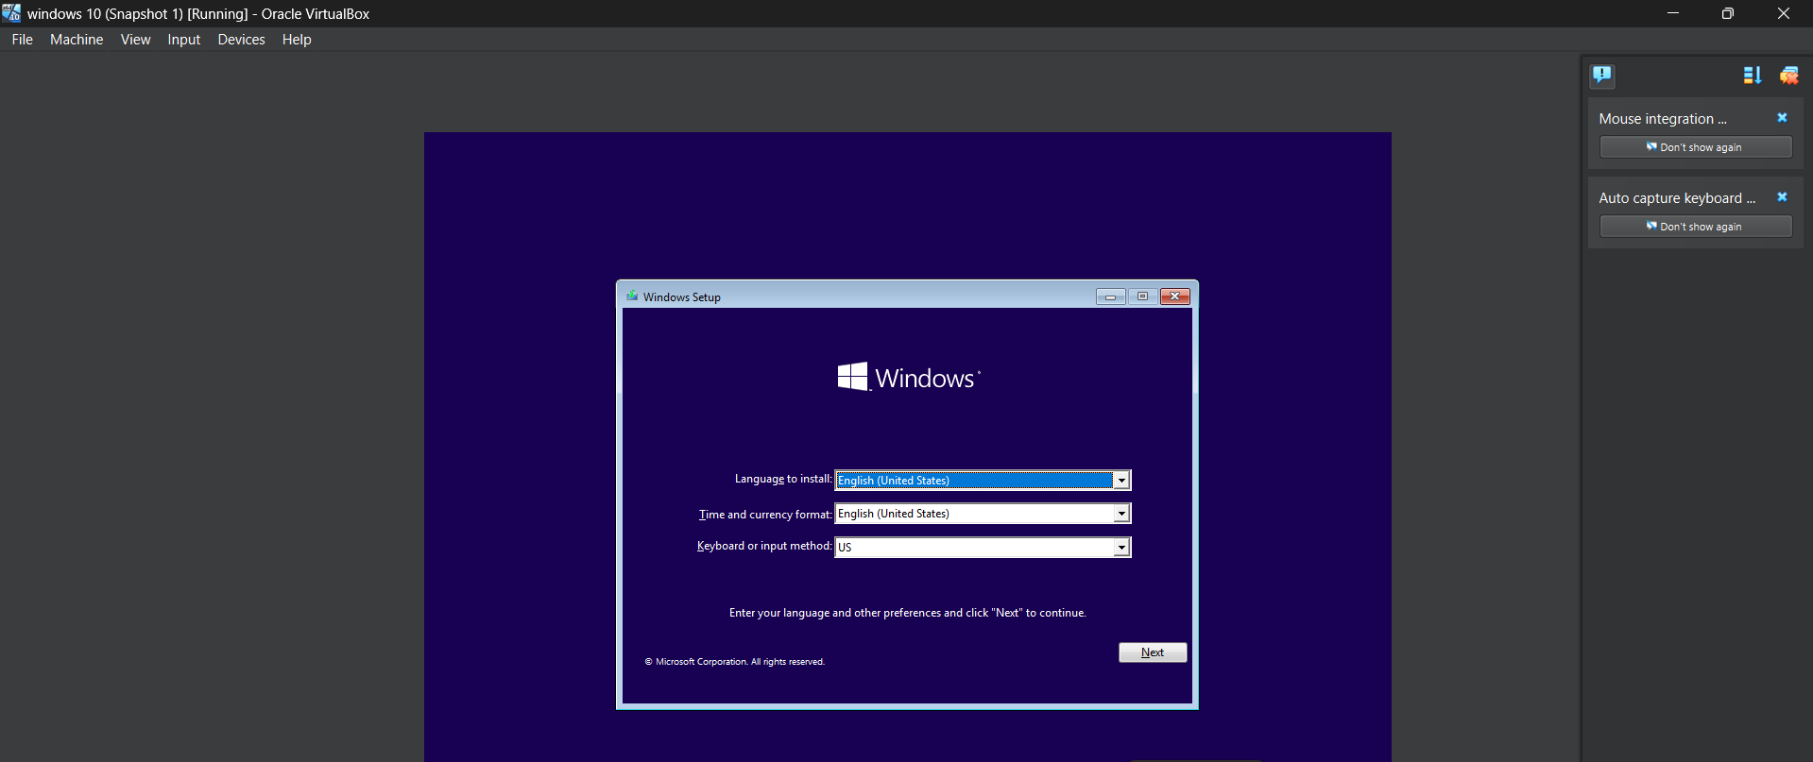

Step 5:

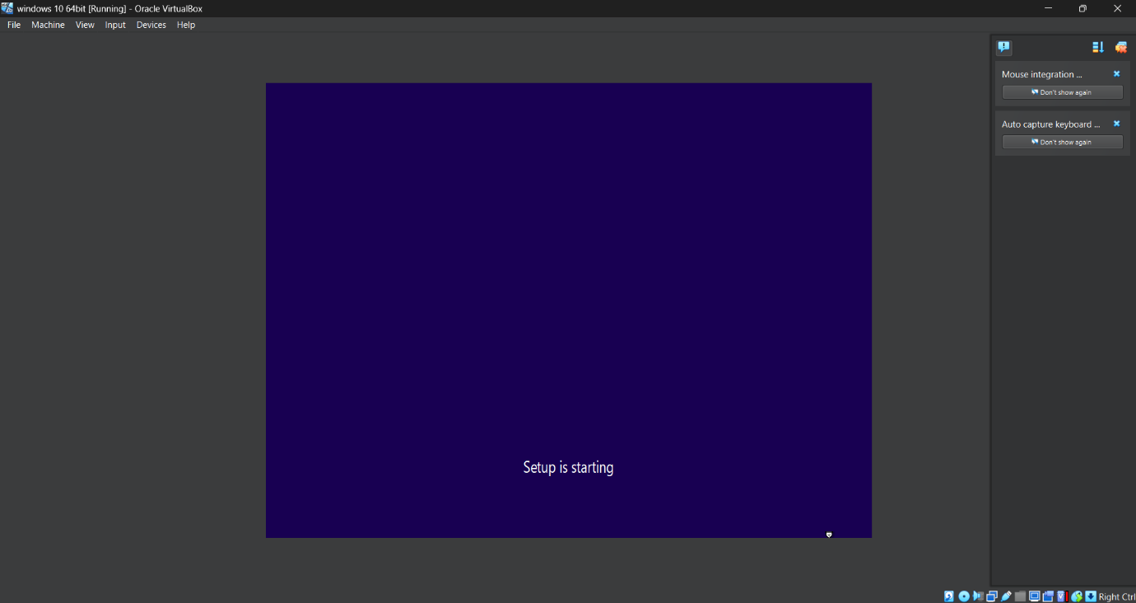

Step 6:

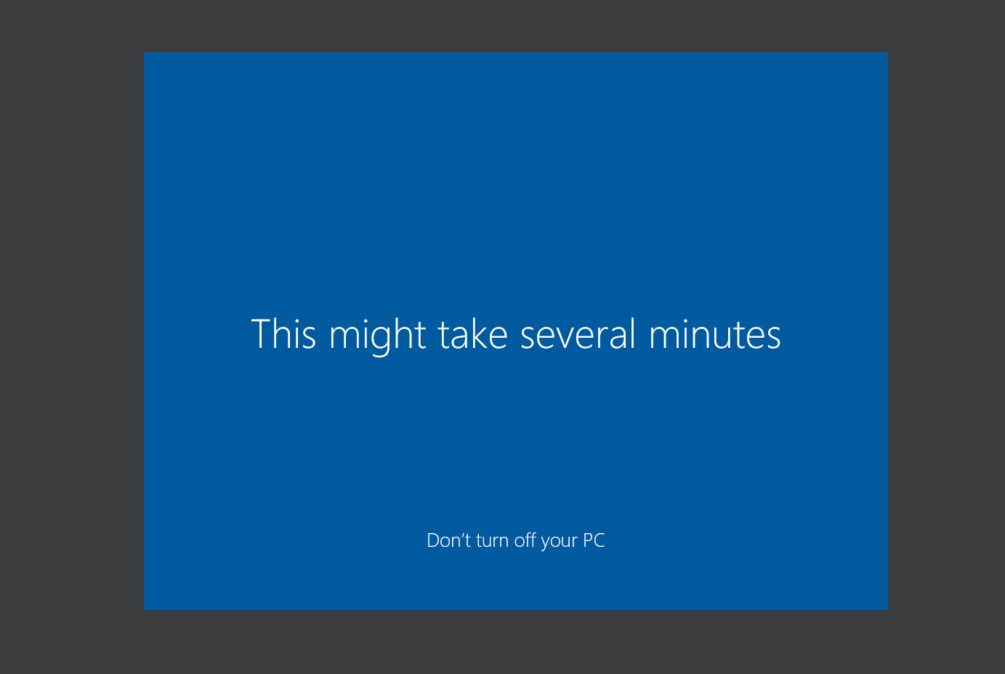

Step 7:

